# Change client settings

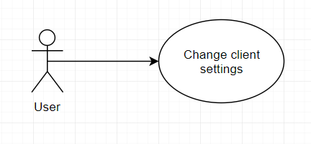

## Characteristic Information

|  |  |
| --- | --- |
| Goal: | The user is able to change the color theme of the interface.  He/ She is also able to change his user data like his/ her username. |
| Precondition: | The user has to log in (have an account). |
| Postcondition: | The client changed his information and the interface color after his liking. |
| Involved User: | The user |
| Triggering Event: | The user is not satisfied with the color or he/she made a mistake about his/her information. |

## GUI to call the use case

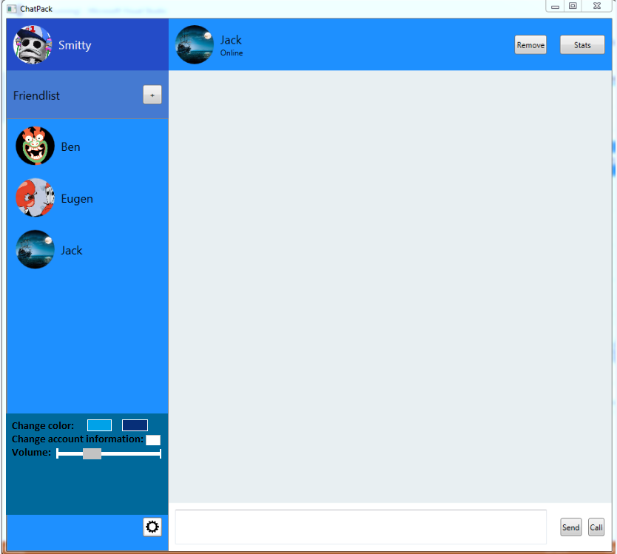

## Scenario for the standard use

| Step | User | Activity |
| --- | --- | --- |
| 1 | User | Log in |
| 2 | User | Click the setting button |
| 3 | User | Change the color, the volume or click the button to change the user information |